Copyright
PROJECT MANAGEMENT SOFTWARE CENTRE 1994-2007
All rights reserved. No part of this publication may be reproduced in any form without the written permission of the PMSC.

Consolidated files

You can consolidate any number of Project Commander files by selecting them from one folder or inserting each file one at a time – even from different folders (say on a network)
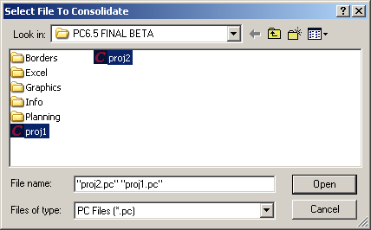
- Select the FILE menu, NEW.
- Click on CREATE NEW PROJECT
- Select the FILE menu, CONSOLIDATION, INSERT.
- Holding the CONTROL key down, click on each project file.
- Click on OPEN.

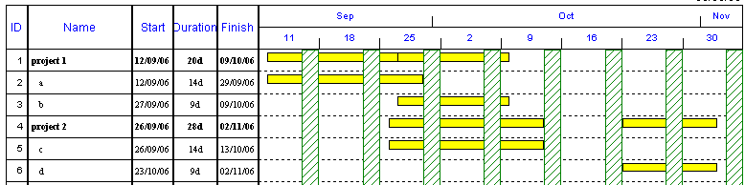

All the files are appended and now all reports can be based on the consolidated information.

If any changes are made in the original files while working on the consolidation, then all the files or selected files can be reloaded.
- Select the FILE menu, CONSOLIDATION, UPDATE.
- Click on SELECT ALL (or choose individual files)
- Click on OK

Important – the latest saved file is used in the consolidation. If it is still open a warning will say the file is read-only and cannot be overwritten.
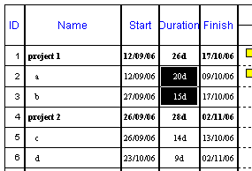
If any changes are made, then they can be saved back to the original files.

- Select the FILE menu, CONSOLIDATION, SAVE.
- Click on SELECT ALL(or choose individual files)
- Click on OK

The file concerned will now be updated..
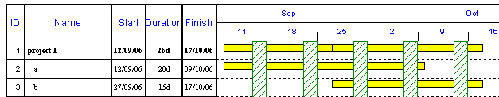

IMPORTANT

It is probably a more pragmatic approach to only do what-ifs in the consolidation and not update the original files from here. It would be better to make the changes needed in the original files to ensure the integrity of those files. Some corruption can occur when saving back automatically from changes in the consolidation or some of the consolidated data for task scheduling can be changed (especially where calendars for resources/projects are different for differing files).

In order to save the consolidated file for future use, select the FILE menu., SAVE AS
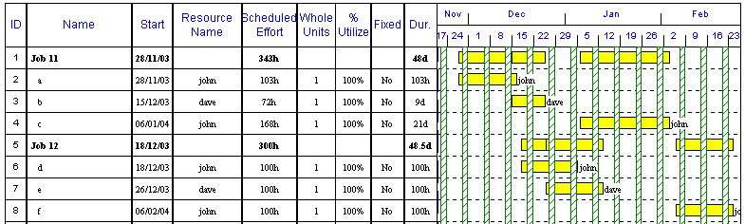

When you open the consolidated file again, you will be prompted to update it.

If files are in different locations on a server, then they can be added one at a time in the consolidation by FILE menu, CONSOLIDATION, and then INSERT.

Once a consolidated file has been built, it can be saved as a normal .PC file by the usual FILE menu, SAVE AS. Later when you open this file, it will ask you if you want to reload the original files – so that the consolidation is totally up to the minute.

There are several important issues that need to be taken into account with consolidation

In Version 6.5 Build 2325 and above.

PROJECTS WITH NO RESOURCES

If the calendars are different in any of the project files, it will use the appropriate calendar for scheduling and allocate each calendar a unique name.

It will not effect the scheduling of tasks in the consolidation.
The shading for weekends and holidays will always use the project calendar in the consolidated file – so preferably all the files should have the same project calendar.

PROJECTS WITH RESOURCES

Resource names in each file must have the same syntax (ie. name is exactly similar in all files) in all files.

The default is set up so that all Resources will use the same Resource calendar for each resource – even though they may be different for each file.
The resource calendars used will either be from an empty template you set up that you use to start the consolidation or the first file consolidated using that resource.

The default is set to use this option and is found in OPTIONS menu, PREFERENCES, DURATION/RES tab and the option below is ticked.
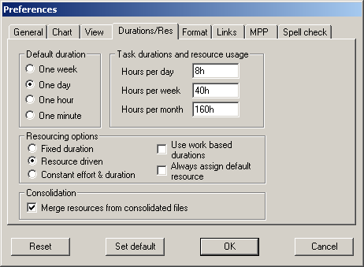

If the above box is ticked off

Each individual resource in each project must have exactly the same calendar or the consolidation will assume it is a separate resource.

NOTE

If the calendar used in the original files is different from the default calendar used in the consolidated file, you can view the name of the calendar and which file the project/task came from – by inserting the fields below…..
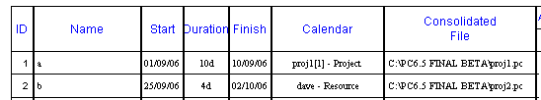

IMPORTANT

If you are consolidating it is important ..

1. That as much as possible is standard (ie all projects should be based on a template).
2. If the template is changed, then the first project inserted into the template should be using the updated template.
3. If resource/project calendars are different in individual files that can cause an issue (as the resource calendars are set to the first file consolidated. This is due to the fact that the OPTIONS men PREFERENCES ..... DURATION tab .. Consolidation / Merge Resources is TRICKED ON and that means the above state will happen. This would mean the project task dates could show in the consolidation different to the original files.

If this option is switched OFF, if the same named resource had a different calendar (even the smallest of changes like an extra holiday day) this would show up as 2 separate identified resources with the same name - but would mean the project task dates show in the consolidation the same as in the original files.

HOW DO I KNOW WHICH FILES THE TASKS CAME FROM?

If you insert a column called CONSOLIDATED FILE, it will tell you the file and path name.

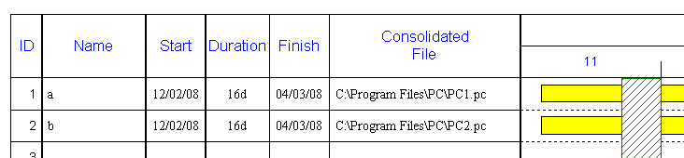

MULTI PROJECTS

If you know that you are intending to consolidate files – then you should make the individual template/project files multi project and record the project name in the PROJECT field.
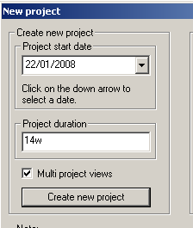
To create a multi project file initially – click on the MULTI PROJECT VIEWS box in the Create New Project window

Or

To insert a project name in an existing file, select the VIEW menu, MULTI PROJECT VIEWS and copy and paste a project name in the Project column.

(If a Project Name is stored on each file it is included in the consolidation and you can view it by inserting the column using VIEW menu, MULTI PROJECT VIEWS in the consolidated file).

